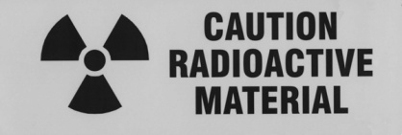
Radiation Safety Committee
SHORT FORM
APPLICATION
NONHUMAN USE OF RADIOACTIVE MATERIALS
{Forms must be typed or very neatly printed in black ink}

Permit Holder Name: Click here to enter text. Date: Click here to enter a date.

Radionuclide: Click here to enter text.

Radionuclide Limits | Per Shipment | Per Year | Possession Limit
Current Limits | mCi mCi | mCi mCi | mCi mCi
Requested Limits | mCi mCi | mCi mCi | mCi mCi

Reason for Request:
Click here to enter text.

The radionuclide for which I am requesting increased limits(s) will be used only in procedures previously authorized by the radiation safety committee.

Permit Holder Signature: _________________________________________________________

Radiation Safety Committee Approval

Date Approved: ________________ Chairman: ______________________________

Interim Approval by Radiation Safety Officer

Date Approved: ________________ RSO: __________________________________

