Understand the importance of the consent process.

Obtaining consent is more than getting a signature on a consent form; it is a process of information exchange that can include recruitment materials, verbal instructions, questions/answer sessions and other efforts used to enhance a participant’s understanding of the research study, both before and after a participant gives consent or signs a consent form. The principal investigator (PI) is responsible for ensuring that each research participant voluntarily gives informed consent before that individual participates in any research activities unless a waiver is granted by the IRB. Thus, rather than an endpoint, the consent document should be the basis for a meaningful exchange between the investigator and the research participant.

Note: “consent form” includes assent forms/HIPAA Authorization forms.

- DO become familiar with the essential elements of the consent form.
- DO train all research staff about the IRB-approved consent process to follow.
- DO make sure the person obtaining consent has IRB approval to do so.
- DO make sure the consent process executed is consistent with the consent process approved by the IRB, including storage location of signed consent forms.
- DO remember to sign all consent materials (consent, assents, HIPAA Authorizations) as applicable to the study and approved by the IRB.
- DO remember to obtain consent from minor participants once they turn 18.
- DO approach the research participant with respect and a positive attitude.
- DO approach the research participant in a private area that is free of interruptions.
- DO review each section of the consent form with the research participant.
- DO inquire if the research participant has questions.
- DO check for understanding. Ask the research participant open-ended questions or use a teach-back method.
- DO allow the research participant sufficient time to read the form; even allowing the research participant to take the form home to read or discuss with family members.

- DON’T be rushed.
- DON’T use medical jargon or language that the research participant might not understand.
- DON’T exert undue pressure on the research participant or family members.
- DON’T minimize the participant’s or family’s concerns.
- DON’T assume there are no questions if the research participant doesn’t ask any.
- DON’T begin any study procedures before the consent form has been signed.

Use the current IRB-approved version of the consent form.

- DO use the consent form templates on the IRB website when drafting your study consent form for the most current required and sample language.
- DO update your consent form when you change study procedures and/or identify new risks to research participants.
- DO obtain IRB approval before using a revised consent form.
- DO obtain re-consent on IRB-approved revised versions as required.
- DO print currently approved consent forms from eIRB as needed.
- DO have a system to verify that correct IRB-approved versions are being used.

- DON’T use expired/outdated consent forms.
- DON’T alter approved consent forms (i.e. adding extra signature lines, changing the expiration date – example below).

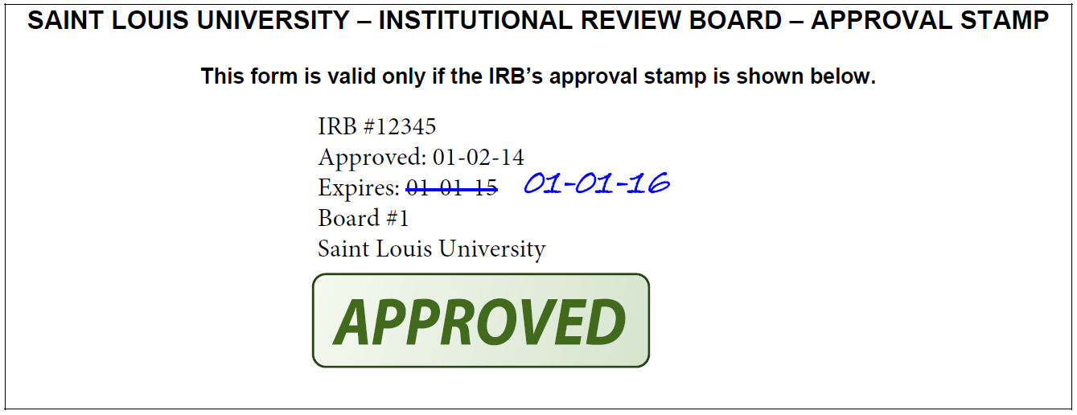

Ensure all items are completed.

- DO verify that the research participant completes all sections on the consent form.
- DO verify that no pages were missing from the consent form.
- DO verify that ink was used to sign the consent form.
- DO verify that participants and the research team member obtaining consent sign and date the form at the same time unless the study design prohibits it (e.g., school-based research where the signature process occurs remotely).
- DO sign one original consent document and make a copy of the signed and dated copy to research participants (instead of signing two original copies) whenever possible (e.g. in field research with no access to a copy machine this may not be feasible).
- DO maintain the original signed copy in the research records.
- DON’T scan and email signed consent forms. Provide a paper copy to the participant.

(Shown below: The SLU IRB allows the signed consent form to serve as documentation that the consent process occurred, but recommends in some studies (e.g., in-patient, decisionally-impaired populations), a consent process note also be written to capture notable details such as time of consent, who was present, etc. Studies using verbal consent can utilize a consent documentation log.)

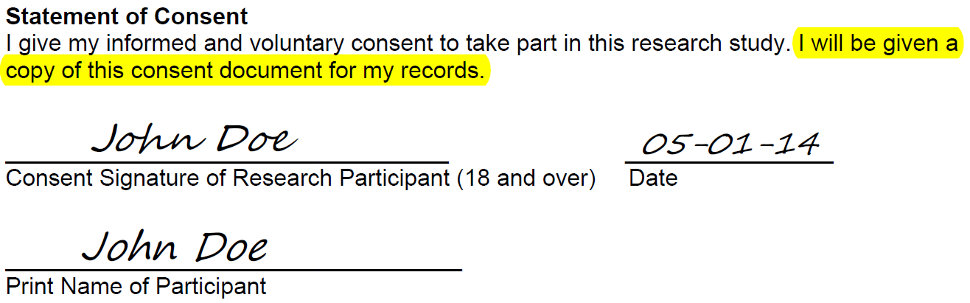

- DON’T leave consent form questions incomplete.
- DON’T confuse initials with checkmarks.
- DON’T fix any errors made by the research participant (i.e. adding checkmarks or dates if participant failed to complete them – shown below).

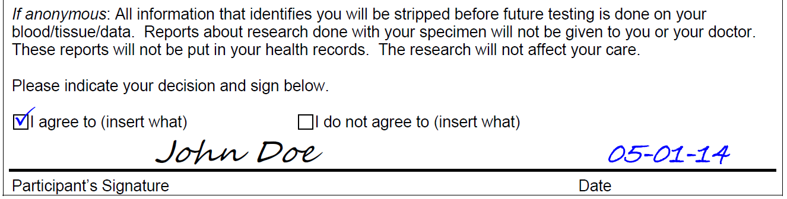

Get all necessary signatures and dates.

- DO verify that the person obtaining consent has signed and dated the consent form.
- DO document that the Legally Authorized Representative (LAR) for a child is the parent or guardian.
- DO document who is signing as LAR for an adult with diminished capacity to consent.
- DO ensure that the appropriate LAR is being determined (see LAR Guidelines).
- DO verify that signers complete all applicable lines on the consent form (i.e. that 2nd parent and witness sign in addition, if applicable for the study – shown below).

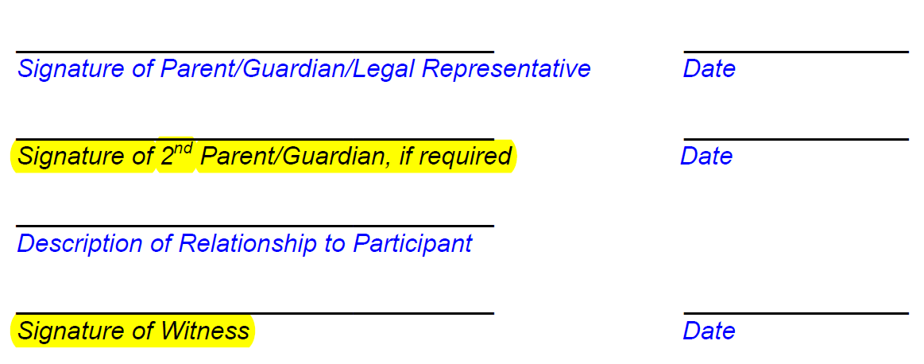

- DON’T leave LAR’s relationship to participant undocumented (i.e., describe relationship to participant – shown below).
- DON’T create new lines on the consent form or have someone sign outside of an approved signature line.
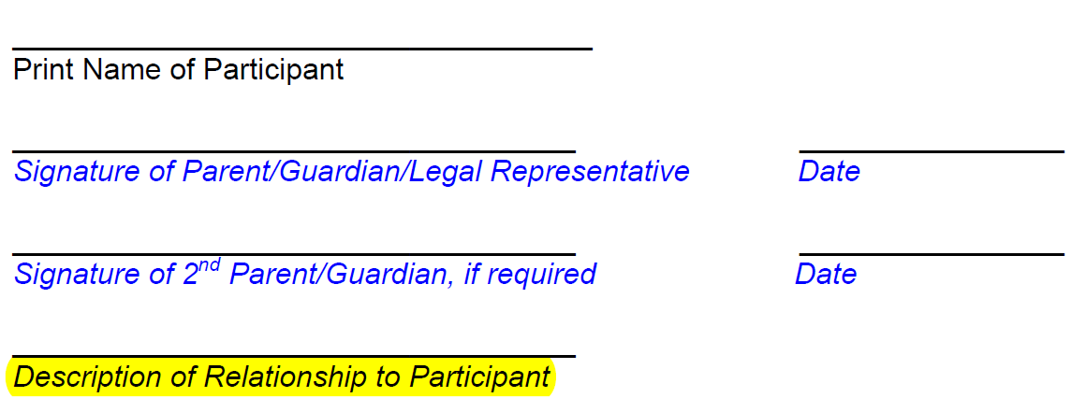

- TIP: Use sticky tabs to indicate all pages that need signatures and/or other responses from signers.

Get all necessary signatures and dates (continued).

- DO verify the research participant includes the date of signing at the time of consent.
- DO have participants make their mark on the signature line if capable of providing consent, but not capable of signing the form. Document explanation in consent process note-to-file.

- DON’T enter the dates for the research participants; they must write it themselves.
- DON’T forge the research participant’s signature (have someone else sign name).
- DON’T ignore ambiguous dates. If needed, explain them in the consent process note to file (example below: “Ju” could mean June or July).
- DON’T obtain extraneous signatures on the consent (e.g., witness on consent without approved witness line), especially without a signed and dated note-to-file.

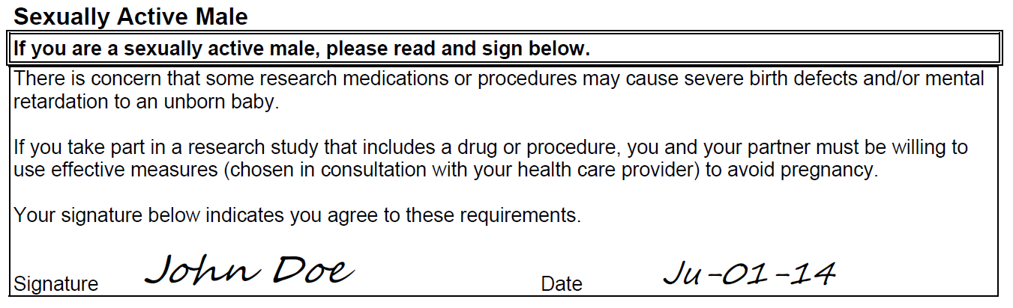

Document the consent process in a Note-to-File.

A potential research participant’s agreement to participate in a research study is usually documented by the participant indicating his/her approval by signing and dating the consent document.

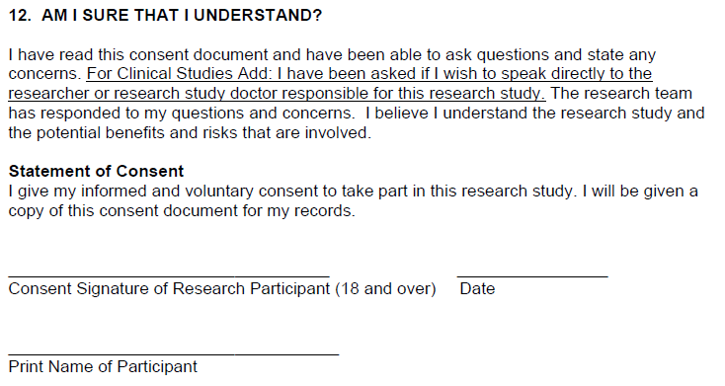

However, there are situations in which the consent document alone will not adequately document the consent process. For these instances, a Note-to-File (a signed and dated consent process note) is expected to document the additional information.

Such situations include, but are not limited to:
- When the consent process differs from the IRB approved consent process;
- When a waiver of written consent has been obtained and verbal consent will be obtained;
- When recruiting decisionally-impaired research participants;
- When recruiting non-English speaking research participants; or
- In-patient studies in order to capture the time of consent.

When the consent process differs from the IRB approved consent process:

- DO document how the consent was obtained and how it differed from the approved process.
- DO document any abnormalities that might have occurred when obtaining consent (e.g., why there would be more than one consent form for the same research participant, why the research participant signed the consent on a different day than the study team member if that not expected per the IRB-approved consent process).
- DO determine whether the event is reportable to the IRB (see Common Consent Errors and Corrective Actions)

When only verbal consent will be obtained:

- DO make sure the IRB has approved a verbal consent process (for non-exempt research, a waiver of written consent has been obtained)
- DO keep a consent documentation log which includes when research participants gave consent and whether or not they received a copy of the consent materials/recruitment statement.

When recruiting decisionally-impaired research participants:

- DO document how the investigator determined capacity to consent (i.e., the extent of cognitive impairment) in order to decide whether the potential research participant could give legally effective informed consent (i.e., mini mental performance data).
- DO describe the research participant’s level of comprehension and decision-making capacity at the time of consent (i.e., did the participant appear to understand, did the participant ask questions, was the research participant alert and oriented, comatose, under influence of medication?).
- DO describe whether the research participant’s legally authorized representative (LAR) was asked to act on behalf of the research participant.
- DO describe how the research participant’s LAR was determined (see LAR Guidelines).
- DO describe whether research participant’s assent was sought (if the LAR provided consent).
- DO know whether the research participant’s failure to assent can be overridden by the research participant’s LAR consent (this requires IRB approval).
- DO describe when periodic reassessment of capacity to consent occurs, how and by whom, if applicable (i.e., in populations where capacity to consent can improve or fluctuate).

When recruiting non-English speaking research participants:

- DO read the guidance for studies involving non-English speaking research participants.
- DO ensure all study materials to be distributed to the research participant are translated to the non-English language of the research participant.
- DO ensure all materials were translated by a certified or qualified translator.
- DO ensure all translated materials have been received IRB approval.
- DO ensure that a witness, who is fluent in the research participant’s non-English language, is present for the consent discussion and study activities.

If a non-English speaking research participant is encountered and qualifies to be enrolled in the study and there is not ample time to translate the full consent form, a short form may be used.

If using a short form:

- DO read the guidance on using a short form consent form.
- DO ensure that the short form consent form is translated to the non-English language of the research participant.
- DO ensure that a written summary that meets the required elements of informed consent (the IRB approved English version of the consent document may serve as the summary) or an oral translation of the full consent form is used.
- DO ensure that a witness to the oral translation of the full consent form is present, if applicable. The witness must be fluent in both English and the non-English language of the research participant. The witness may be the interpreter (including the hospital interpreter), study staff, a family member, or other person not on the research team.
- DO verify whether the interpreter will also be able to serve as the witness, before starting the consent process. If not, identify another person to act as the witness.
- DO verify that the short form document is signed by the research participant (or the research participant’s LAR).
- DO verify that the short form document and the summary are signed by the study team member obtaining consent, witness, and PI (if FDA regulated research).
- DO ensure that the research participant was given copies of both the short form document and the written summary of what was presented orally.
- DO write a summary of pertinent details of the consent process in a signed and dated note-to-file.

What to do when you notice a consent process/documentation error:

- DO write a signed and dated note-to-file.
- DO determine if the error is reportable to the IRB and/or reportable to the sponsor (see Common Consent Process Errors and Corrective Actions).
- DO realize that mistakes happen! The key is timely identification, reporting, corrective action and implementation of changes/controls to minimize the change of repeating it.
- DO report the error as appropriate (to sponsors/IRB).
- DO call the IRB with any questions.
- DO have the person who made the error cross out the error with a single line and date with initials if correcting error immediately (same visit/day of consent process).

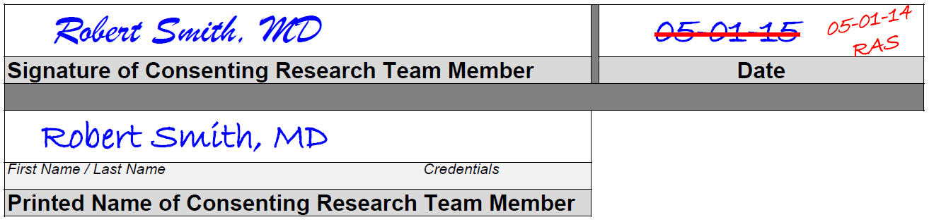

- DON’T make any corrections on the form itself if it cannot be corrected by the person who made the error on the same day of the consent process.
- Errors identified after the day of consent typically require repeating the signature process on a new form (often referred to as “re-consent”). SLU recommends the re-consent process be done in-person [rather than via mail] especially if the consent form contains health or other sensitive information. In regard to timing, re-consent should occur prior to any activities/events take place for which consent is not clearly captured. In some cases it may wait for the next visit (e.g., missed section was for optional blood draw that will be drawn at an upcoming visit). In other cases it may need to be obtained ASAP and before activities without explicit consent take place.

- DON’T correct errors for anyone other than yourself on the form itself.
- DON’T use white out.
- DON’T obscure the original entry.
- DON’T back date.
- DON’T fabricate information.
- DON’T delay filing the signed consent document in the designated secure location.
- DON’T assume people know your consent process and what you did*.

- REMEMBER: If it isn’t documented, it didn’t happen!

